Help Us Spread the Word About Skin Cancer

Long-term exposure to ultraviolet (UVA and UVB) radiation damages your skin’s top layer. It increases your chance of developing skin cancer — the most common form of cancer in the United States. The sun produces UVA and UVB rays, but so do tanning beds and sunlamps. They have been linked to malignant melanoma, the deadliest form of skin cancer. And they should be avoided.

The below social media content is for use on school and educator social media channels and for parents to share with their children. Schools, superintendents, principals and individual teachers often have high student followings, and are excellent places to share information about staying smart in the sun.

Delaware Division of Public Health Social Handles
https://business.facebook.com/HealthyDE/
https://twitter.com/Healthy_DE
https://www.instagram.com/healthy_delaware/

Posts By Week

ˆWeek One
(Post Copy)
If you think you look healthier with a tan, you’re fooling yourself. Damaging rays can cause skin cancer and melanoma that can threaten your life. Learn more at protectyourskinde.com.

(Post Image – Save to your computer and upload with copy)

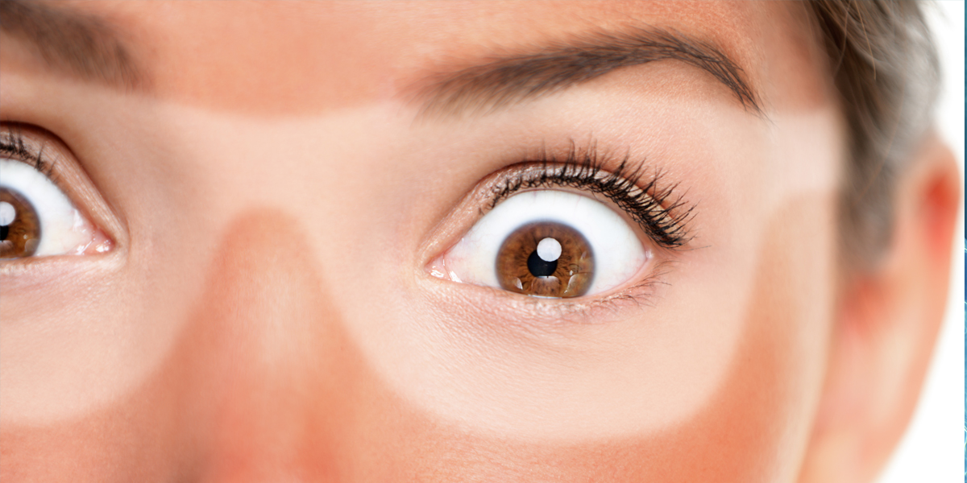

Week Two
(Post Copy)
The melanoma incidence rate increased more than three times faster in Delaware than nationally over the past 10 years. Don’t become a statistic – learn about sun safety at protectyourskinde.com.

(Post Image – Save to your computer and upload with copy)

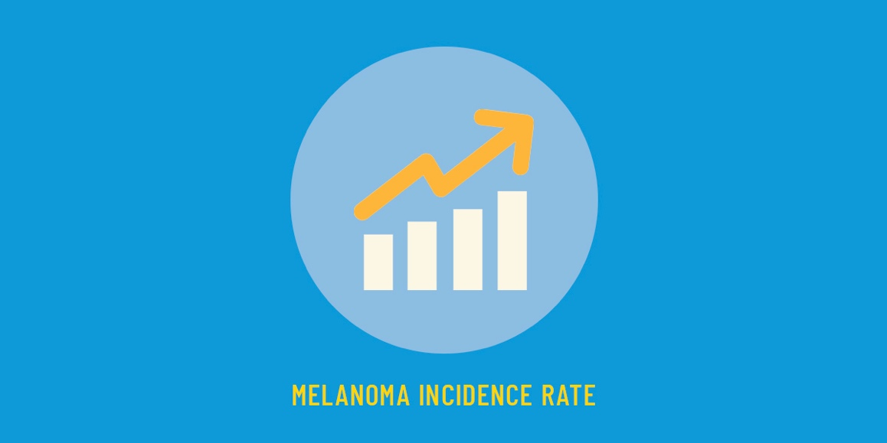

Week Three
(Post Copy)
Sunscreen doesn’t last all day – you need to reapply! Use a water-resistant sunscreen with UVA and UVB protection and a broad-spectrum SPF of 30 or higher. Apply it liberally and reapply every two to three hours, or more frequently if you’re swimming or sweating.

(Post Image – Save to your computer and upload with copy)

Week Four
(Post Copy)
Tanning beds might seem like a good idea, but they give you a lot more than a temporary glow. Tanning beds increase your melanoma risk 75% before age 35.

(Post Image – Save to your computer and upload with copy)

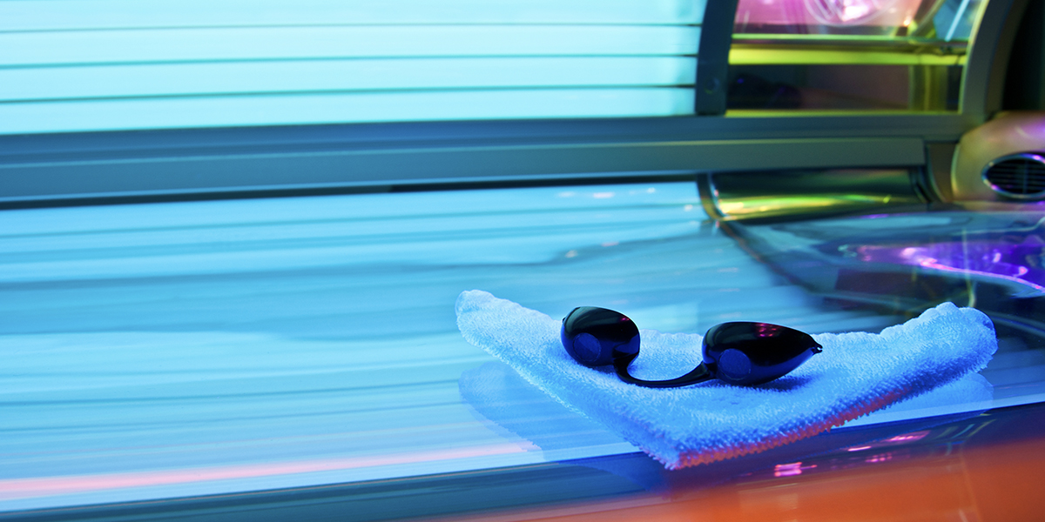

Week Five
(Post Copy)
Can you find these sun-smart words in this wordsearch?
Hat
Lip Balm
Long Shorts
Shirt
Pants
Sunglasses
Sunscreen
Tree
Shade

(Post Image – Save to your computer and upload with copy)

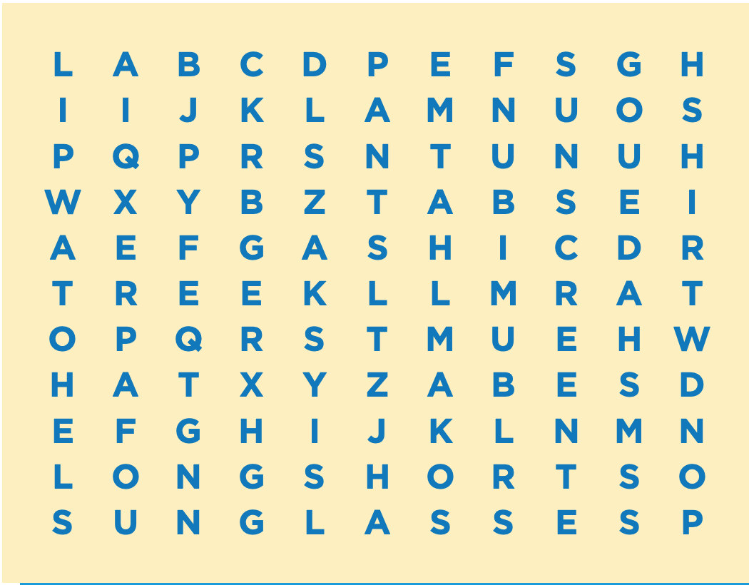

Week Six
(Post Copy)
Which of these sun safety action steps are part of your routine?

(Post Image – Save to your computer and upload with copy)
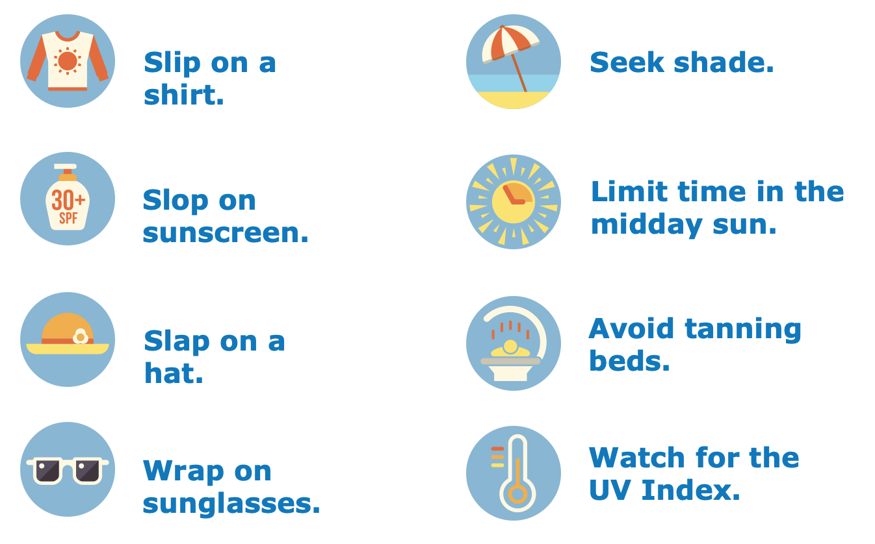

Week Seven
(Post Copy)
Make sure you’ll be here to enjoy every summer to come by knowing the facts about what can put you at risk for skin cancer. Visit protectyourskinde.com to learn more.

(Post Image – Save to your computer and upload with copy)

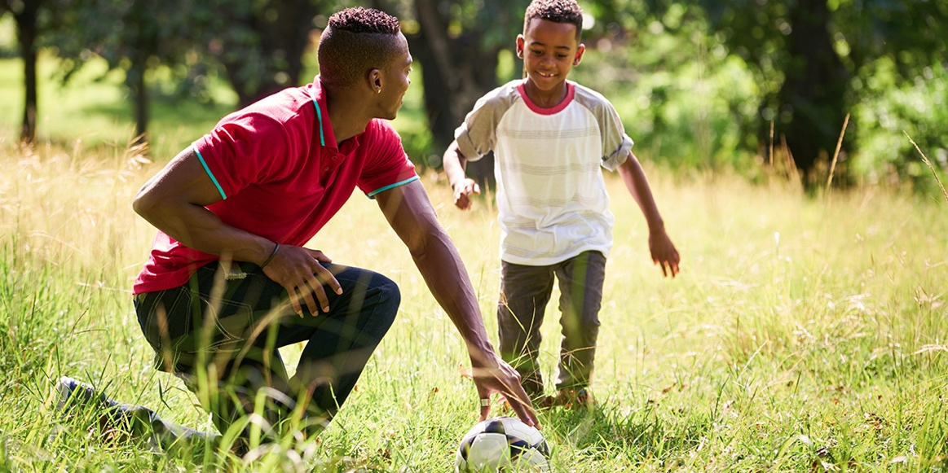

Week Eight
(Post Copy)
Playing in the shade or under an umbrella when the sun’s rays are strongest (10 a.m. to 4 p.m.) can help lessen your risk of skin cancer. Learn more at protectyourskinde.com

(Post Image – Save to your computer and upload with copy)

Week Nine
(Post Copy)
Some things that happen to you—or are just part of the normal pattern of life—could put you at risk for skin cancer. Learn more at protectyourskinde.com.
(Post Image – Save to your computer and upload with copy)

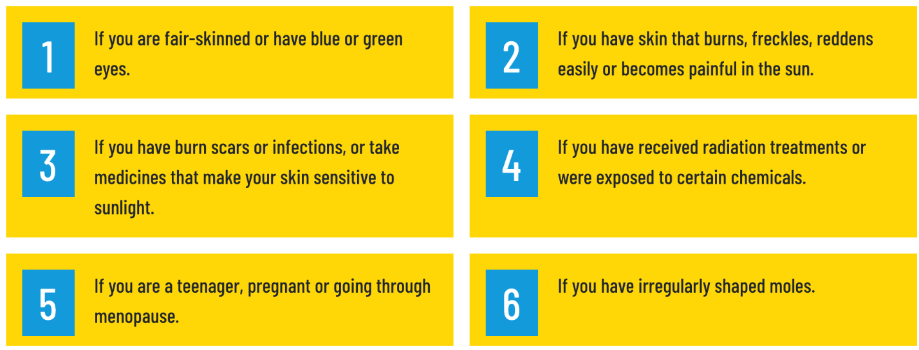

Week Ten
(Post Copy)
UVA and UVB radiation from the sun, tanning beds and sunlamps can all damage your skin and cause potentially deadly skin cancer. Find out how to protect your skin at protectyourskinde.com.

(Post Image – Save to your computer and upload with copy)

